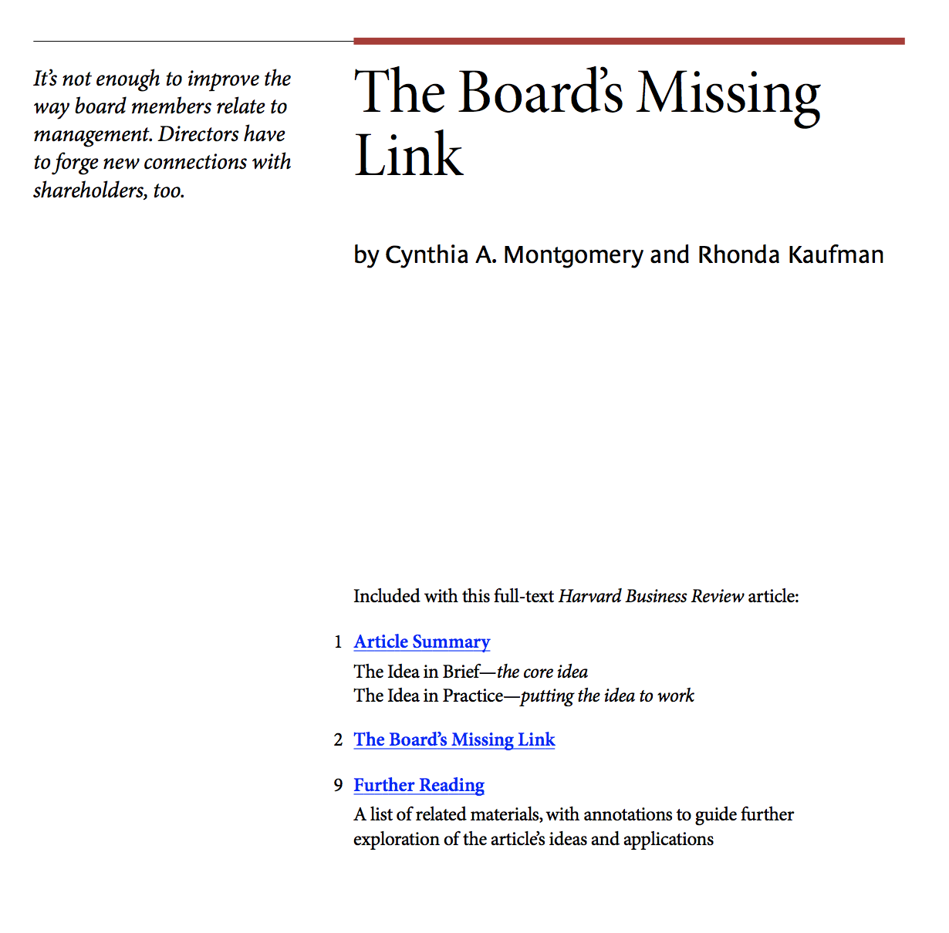

**The Idea in Brief**

In the wake of corporate failures, how can you ensure effective governance of *your* company? Support mutual accountability and unfettered information exchange among all three players in the governance triangle: shareholders, management, and the board of directors. These players’ inter- relationships form a powerful set of checks and balances that constitute the very foundation of corporate governance. Neglect any one link, and that foundation becomes dangerously unbalanced.

Two relationships—shareholders–management and management–board—have lately improved, owing to pressure from the SEC, other regulatory groups, and market forces. But that third link—shareholder– board—remains largely ignored. It’s riddled with weaknesses that threaten the entire system’s equilibrium.

Until we address those shortcomings, efforts to strengthen the triangle’s other two links are doomed to fail.

**The Idea in Practice**

**FLAWS IN THE SHAREHOLDER–BOARD RELATIONSHIP**

The shareholder–board relationship has two serious flaws:

* **Poor exchange of information between boards and shareholders.** Directors aren’t individually accountable to investors. During voting, for example, only those in the boardroom know how each director voted. Investors have no way to know if individual directors are serving their interests.
* **Shareholders’ failure to influence boards.**
  1. Shareholders don’t communicate their preferences to boards. Though shareholders have the right to elect directors, they usually receive one-candidate slates driven by the CEOs. Lacking information on individual directors’ performances, they can’t make in- formed choices at reelection time. More- over, their feedback to the board is limited to formal proxy votes, which often simply ratify management’s wishes. Result? Directors face the Herculean task of representing people whose preferences are unclear and who rarely provide feedback. And shareholders have little say about who represents them and few mechanisms for effecting change. 
     + 1. **THE PRICE OF IMBALANCE**

When shareholders fail to set direction or hold board members accountable, an important link in the governance system is missing. The entire governance system suffers. Lacking guidance from shareholders, directors turn to fellow board members and management to fill the information void. A cordial, consensus- driven environment emerges, where even in- dependent directors hesitate to question CEO preferences and majority views.

**RIGHTING THE IMBALANCE**

To strengthen the shareholder–board link:

**Make directors accountable to shareholders** by publishing individual directors’ votes on key corporate resolutions in proxy statements. When accountable for their actions as *individuals*, rather than as a group, directors will weigh their choices more carefully. And shareholder organizations could use accumulated voting information to create director scorecards.

**Separate the positions of chairman and CEO** to maintain balance in the boardroom and support the governance triangle’s checks-and-balances system.

**Reinvigorate shareholders** so they step up to their responsibilities as owners and actively engage with boards. Shareholders should clearly signal their endorsement (or lack thereof ) for board candidates by, for example, publishing their proxy-election votes and voting rationales on their Web sites—and delivering this information directly into boardrooms. They should also convey their decisions—and rationales— on management proposals.

**Give boards budgets** for hiring outside experts to grapple with complex issues, such as a bet-the-company merger decision. Management’s presentations will likely be- come more balanced and comprehensive if they know directors may call in independent advisers.

If a dike or dam has sprung a number of leaks, there are many possible ways to respond. The initial impulse is to assiduously plug one hole after another, hoping that the situation will right itself. Another approach—and often a more sensible one—is to step back, locate the source of the leaks, and correct the underlying weaknesses. When it comes to corporate governance, for too long we have relied on the first approach. It’s time to take a deeper look, see where the stressors in the system lie, and commit to structural reforms.

In the wake of recent corporate failures, numerous suggestions have been made about how to improve governance. Though strongly worded, many of these are surprisingly modest in nature—much like plugging holes in a dike. In fact, nearly all the suggestions lie well within the existing framework of corporate governance. Few reformers have stopped to ex- amine the adequacy of that framework in practice or its ability to support the kinds of changes that are being suggested. The causes of many governance problems lie well below the surface, in critical relation- ships that are not structured adequately to sup- port the players involved. In other words, the very foundation of the system is flawed. Unless these flaws are corrected, surface changes are unlikely to have a lasting impact on the state of corporate governance.

**The Balance of Power**

The corporate balance of power is a delicate one. It relies on three critical anchors—share- holders, management, and the board of directors. Each of these has important responsibilities of its own, but their interactions are the key to effective governance. When they work together as a system, they provide a powerful set of checks and balances. But when pieces of the system are missing, or not functioning well, the system as a whole can become dangerously unbalanced.

All three relationships in the governance triangle (shareholders–management, management–board of directors, and board of directors–shareholders) depend on mutual accountabilities and an unfettered exchange of information (see the exhibit “The Corporate Governance System”). Consider the relation- ship between shareholders and management, for example. Investors provide capital, and in return, management is responsible for running the company well and delivering timely and accurate financial reports. Influential groups such as the SEC and the New York Stock Ex- change have targeted this relationship for re- form. Even the U.S. Congress has weighed in. As a result, reporting standards and regulations that promote transparency are stronger than ever.

The relationship between the directors and management has received a lot of attention, too. The board monitors performance, counsels management, and—most important— hires, fires, and sets compensation for the CEO. The CEO, in return, is responsible for managing the company and keeping the board in- formed about how things are going. New governance guidelines that touch on this relationship have focused primarily on board and committee composition. They call for an increase in the number of independent directors, and they require critical committees—audit, nominating, and compensation—to be composed entirely of independent directors. These moves are designed to distance the board from management and thereby prevent conflicts of interest that can compromise the relationship.

Certainly these efforts will help establish a healthy distance between management and boards. But just as certainly, they will fall far short of what is needed, because they alone cannot balance the governance triangle. To do that would require strength in the last relation- ship as well—that between shareholders and boards of directors. Unfortunately, this essential relationship is fraught with weaknesses that undermine the entire system’s equilibrium. Until these shortcomings are addressed, piecemeal efforts to shore up the other relationships are bound to fail.

**The Shareholder–Board Relationship**

The link between shareholders and the board has received far less scrutiny than the other relationships in the corporate governance triangle, but it is equally important to the overall health of the system. While the other key relationships have been molded by regulatory groups and market forces, this relationship has largely been left on its own. Lacking much attention, standards of practice have been slow to evolve.

Most efforts to enhance this relationship have focused on aligning directors’ financial interests with those of shareholders, often by giving options or outright grants of stock to directors. Stock may be a strong motivator for a CEO, but it is a much less powerful incentive at the board level. Generally, a majority of the CEO’s personal wealth is tied to the company. But many directors are CEOs themselves, and the bulk of their wealth rests with their own companies. Further, directors serve on boards for numerous reasons other than financial gain. Many find that board service helps them stay on the leading edge of management practice and enhances their professional reputations. At a more personal level, serving on a board gives directors prestige and other intangible perks associated with membership in an exclusive club. Almost all of these benefits can be had whether or not the stock is soaring.

The focus on financial incentives has di- verted attention from a much deeper problem. Transparency and accountability, which rest at the heart of good governance, are essentially missing in this relationship. The exchange of information between these two players is poor, and shareholders, for various reasons, have failed to exert much influence over boards. In short, directors don’t know what shareholders want, and shareholders don’t know what directors are doing.

Though elected by shareholders to serve as their agents, directors are not individually ac- countable to the investors who have placed them on the board. Although votes on resolutions are dutifully taken, only the people present in the boardroom know how each di- rector voted. As unbelievable as it may seem, shareholders have no legal right to know whether directors have, in fact, acted in their interests.

The heart of representative government de- pends on transparency. What would happen if the voting records of civic leaders were secret? How faithfully would they represent their constituents’ interests? Even if current proposals for board reform are adopted, the shareholder will still be left in the dark—an untenable position for an owner.

Not only do directors fail to provide feed- back to shareholders, shareholders—for a variety of reasons—are not successful at communicating their preferences to boards. On paper, shareholders have the right to elect boards, but in practice, they have very little influence over who fills the seats. Voters are almost always presented with a fait accompli—a slate with one candidate per seat. No efficient mechanism exists for shareholders to nominate or even endorse director candidates. Shareholders’ interests are no better served at reelection time. Because they have little information about the performance of individual board members, it is difficult for them to make in- formed choices. Shareholders therefore often have only a blunt instrument with which to make changes. In most cases, they vote the entire slate in or out; the information to support surgical strikes just isn’t there.

Shareholders are even more out of the picture when we consider who creates the slate of nominees. While it is becoming more common for board nominating committees to identify and endorse candidates, CEOs remain closely involved in the process. There are practical reasons for this: CEOs know best where their companies’ weaknesses are, and the CEOs’ personal reputations are often crucial in candidates’ decisions to sign on. That said, there is an important difference between CEOs having input into the director nomination process and CEOs driving the process. When CEOs wield undue influence in director recruitment, they affect board dynamics on multiple levels and send subtle signals as to who is calling the shots. Unless directors actively influence the pool of candidates and the type of person nominated, the CEO will set the tone and composition of the board for years to come.

Even beyond these structural constraints, shareholders have been remarkably lax in making their preferences known. Their communication has mostly been limited to formal proxy votes, which historically have reflexively ratified management’s wishes. Recent activity from some institutional investors suggests that shareholders may begin to flex their muscles and vote their shares in deliberate ways. But in the absence of an unusual proxy fight, investors have generally been mute.

In the end, these conditions leave directors with a Herculean task: faithfully representing shareholders whose preferences are unclear and who rarely provide feedback. The view from the other side is not much better. Share- holders have little say about who represents them and few mechanisms through which to effect change. It’s not surprising that the sys- tem breaks down.

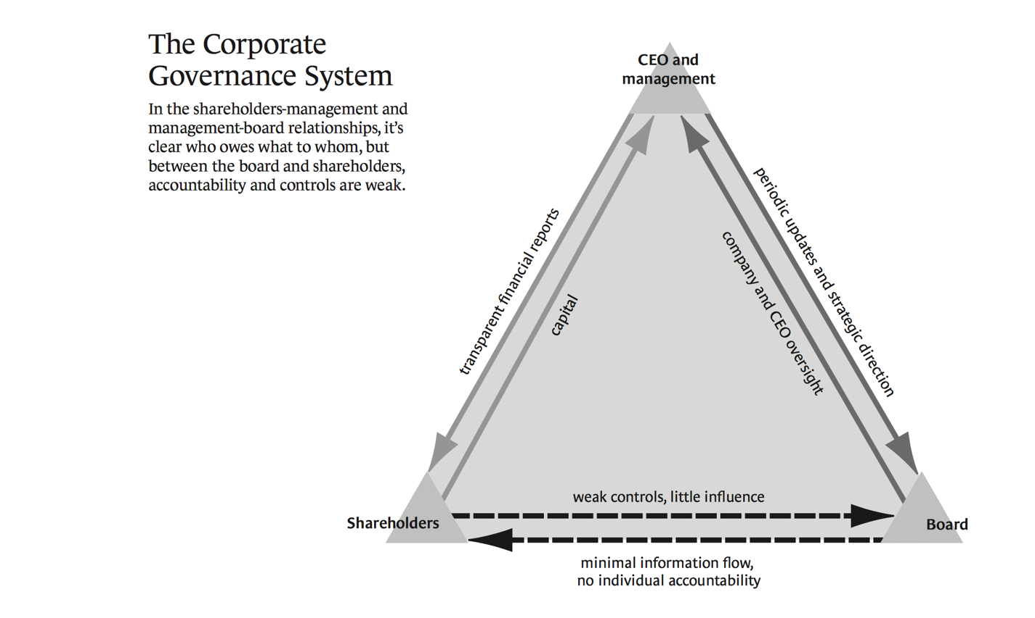

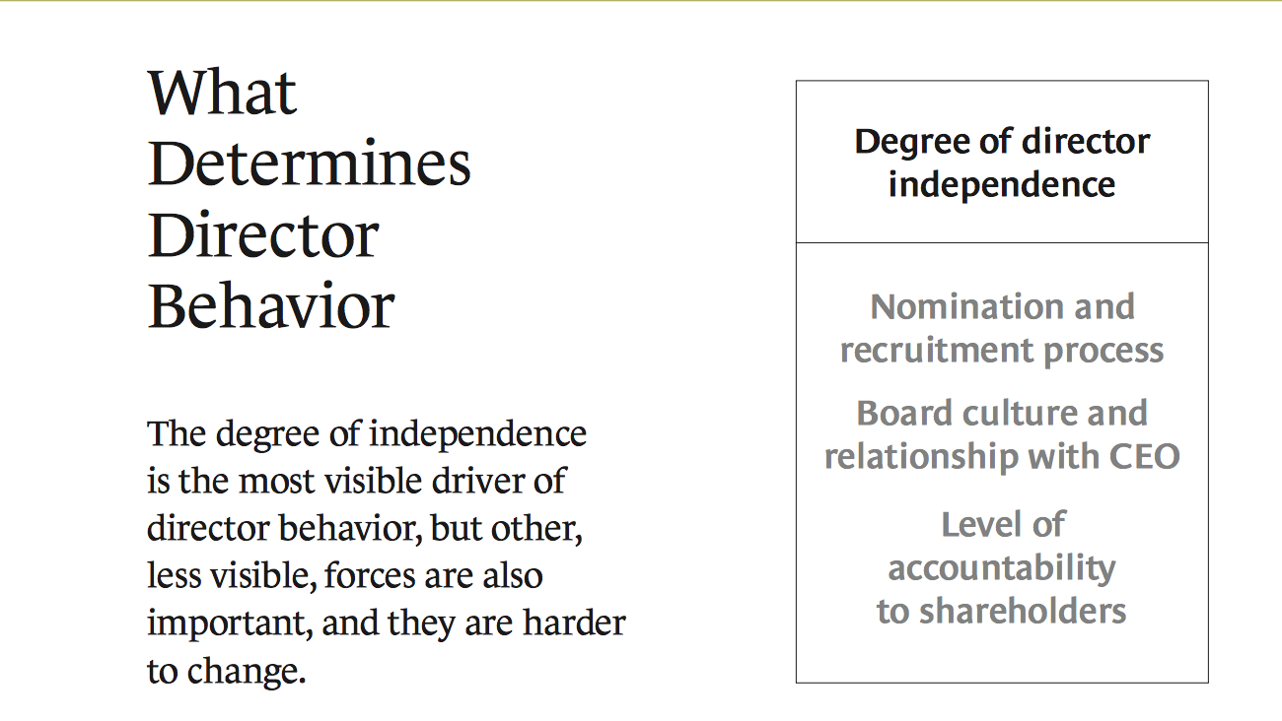

**Governance Without Balance**

When shareholders fail to engage, either in setting direction or holding board members accountable for their behavior, an important link in the governance system is missing. In this context, a director’s allegiance shifts from its proper base—the shareholders—to the nearby boardroom, where fellow directors and management fill the void. This movement skews the governance triangle, moves directors closer to management, and sets the stage for the cordial, consensus-driven environment for which boards are widely criticized.

In such settings, the power and influence of the CEO can be formidable. As we have already seen, this influence may begin with the nomination process; directors frequently feel an obligation to a CEO who has helped recruit them. In addition, CEOs are generally very persuasive people—they have earned their positions, in part, by being able to get things done through others. Their ability to influence directors, on many levels, can have a powerful effect on boardroom dynamics.

Many reformers believe that a critical mass of independent directors will create a board- room climate that will right this imbalance. However, board cultures have a lot of inertia; the likelihood that directors will be conditioned by the existing climate on a board, rather than create a new one, is high.

Consider the forces at play when an individual joins a board. Typically, new members are added one or two at a time. This means that each new director is joining a group with al- ready established norms. As astute observers of human behavior, directors soon learn the un- written rules and elaborate dances that are part of a company’s board culture. Not surprisingly, directors often learn to be reticent about raising objections in the face of expert opinions, CEO preferences, and apparent majority views. Directors may ask thoughtful, probing questions, but there is a big difference between making a polite inquiry and mounting an adversarial challenge to the prevailing mind-set. (For an example of these forces at work, see the sidebar “A Recipe for Poison Pills.”)

Admittedly, this level of passivity is not what one might expect from a group of highly accomplished people in leadership roles. What accounts for it? Quite simply, internal board dynamics take on primary importance when shareholders are remote. Lacking an external counterweight, directors—even those with all the chevrons of independence—often find it difficult to move boldly against the tide, especially in the absence of crisis conditions.

When directors receive neither kudos nor censures from shareholders, their risk equation lies squarely in the boardroom. In this context, the determined pursuit of an issue on behalf of shareholders requires the expenditure of political capital and emotional energy—potentially big costs to a director with few compensating benefits. When time pressures and lack of adequate information are added into the mix, the path of least resistance can become very tempting.

Does this mean that without rewards or fear of negative consequences, directors—even very good ones—will do bad things? Not necessarily. The much greater likelihood is that they just won’t be as vigorous in doing good things. In a job where vigilance is of primary importance, this is a major concern.

**Righting the Imbalance**

The compromised boardroom climate is a serious obstacle to good governance. Proposals for reform that focus on *who* sits at the table address only the surface of the problem. As Deming told us long ago, poor outcomes are more often the result of bad processes than bad people. (See the exhibit “What Deter- mines Director Behavior.”) The weak share- holder–board relationship creates an untenable situation for directors. If we expect them to do their jobs, we must give them a structure in which they can be effective.

**Make directors accountable to shareholders.** One compelling way to increase board accountability is to record individual directors’ votes on key corporate resolutions in proxy statements. As Louis Brandeis said in his 1914 treatise *Other People’s Money, and How the Bankers Use It*, “Sunlight is said to be the best of disinfectants....But the disclosure must be real....To be effective, knowledge of the facts must be actually brought home to the investor.”

Most of our social contracts are built on the assumption that individual accountability influences human behavior.

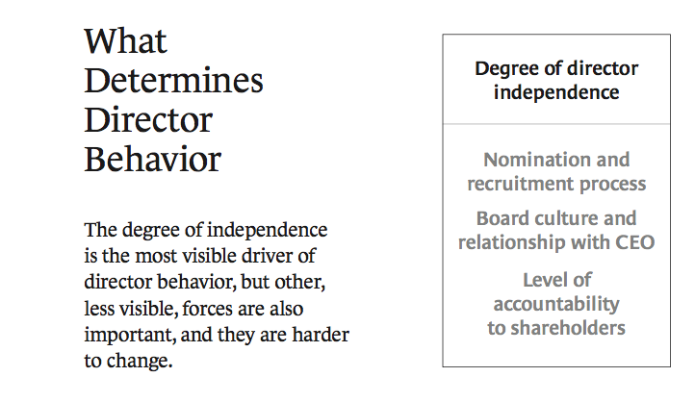

Indeed, the recent move by the SEC to require CEOs to personally attest to their companies’ financial statements aims to renew CEOs’ sense of accountability. The expectation is that, by affixing his or her name to the document, the CEO will verify its accuracy by asking more rigorous questions: Do I trust the level of analysis? Am I getting the right advice from the right people? Do I need more information? It should be the same in the boardroom. When people are held ac- countable for their actions as individuals rather than as a group, they tend to weigh their choices more carefully. If individual votes were published, directors would have greater incentive to air their views, thus improving the level of boardroom debate.

As voting information accumulates, share- holder organizations such as Institutional Shareholder Services could use the balloting data to create director scorecards. Such objective information, and any accompanying analysis, would serve as a much-needed supplement to board self-evaluations. (See the sidebar “Are Board Self-Evaluations Enough?”)

**Separate the positions of chairman and CEO.** This suggestion is hardly novel—in fact, splitting the positions is a common practice in many boardrooms outside the United States— but in light of our model of corporate governance, it’s clear why separating these two roles is vital for maintaining balance in the board- room. Companies that fuse the roles of CEO and chairman collapse the governance triangle, undermining the system of checks and balances that is essential to responsible corporate governance.

**Reinvigorate shareholders.** As Michael Jensen observed in a 1993 *Journal of Finance* article, “Financial institutions such as banks, pension funds, insurance companies, mutual funds, and money managers are natural active investors, but they have been shut out of boardrooms and strategy by the legal structure, by custom, and by their own practices.”

There are many reasons why shareholders have remained on the sidelines of governance. Proxy battles are expensive and time-consuming, a lack of information has hampered the oversight process, and institutional investors have been slow to recognize the power their votes could wield. However, as we have seen, the corporate governance system will not function properly until shareholders step up to their responsibilities as owners and actively engage with boards.

To start, in the nomination and election process, shareholders could signal their sup- port (endorsement, neutrality, or non endorsement) for candidates the board puts forth and vote accordingly. If informed by director score- cards, these recommendations could be even more specific and linked to the performance of individual directors. Some large pension funds like CalPERS, as well as some smaller, socially based funds, are moving in this direction. These funds use their Web sites to publish their governance principles, their votes in proxy elections, and the rationales for the votes they cast.

We applaud these initiatives and urge others to follow suit. Further, this information needs to be delivered directly into the board- room. Posting principles and votes on Web sites may be sufficient to inform investors of a fund’s activities, but if funds want to influence boards, they need to be more strategic in get- ting this information to directors. In cases where shareholders vote against management proposals, efforts should be made to convey those specific decisions, and their rationale, to the board. With this information, directors’ behavior may change; otherwise, the likelihood is high that board members will continue to be unaware of their shareholders’ displeasure.

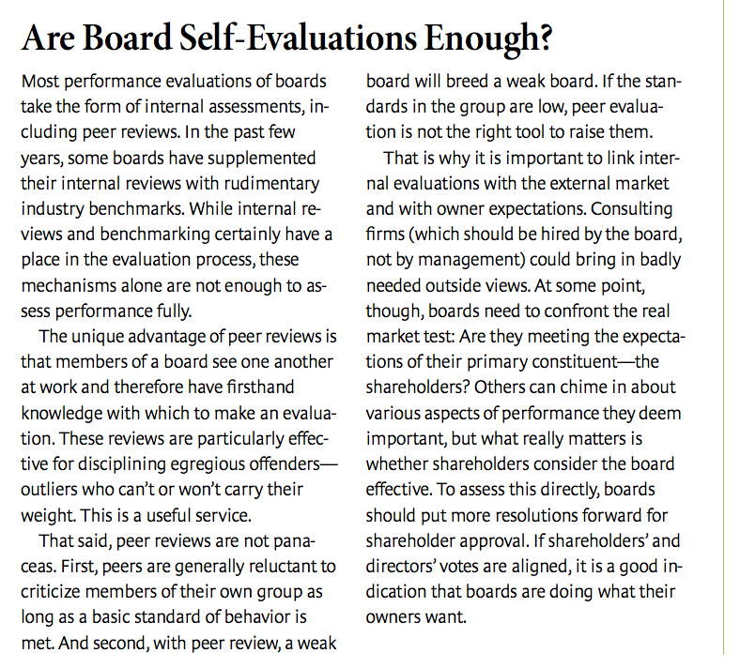

We would also urge shareholders to seek each other out and to work in concert on issues on which they share common ground. While the votes of one institution may not have much impact, those of a critical mass of like- minded institutions very well might.

Over time, active investors could go a long way toward righting the imbalance in the corporate governance system. When boards and managers believe there is a real chance that shareholders will push back on the director slate or block an initiative, their behavior and decision-making processes will shift accordingly. To the casual observer, things may look the same, but the ether in the boardroom will surely be different.

**Give boards funding.** In the course of nor- mal events, most boards can function well with information provided by management. But on certain Gordian issues—a bet-the- company merger decision, say, or a complex product-liability concern—insight from an external perspective could be very useful.

Although circumstances requiring such experts may be relatively rare, it is important that both management and the board operate with the knowledge that this option is avail- able and that its use is not in itself a criticism of management. When management seeks board approval for a proposed action, it naturally attempts to show the proposal in the best possible light; its presentations are likely to be more balanced and comprehensive if management believes that directors might seek an in- dependent opinion.

It should be noted that there is a precedent for providing directors with independent funding: The Sarbanes-Oxley Act requires that audit committees have their own funds for paying auditors and advisers. Giving budgets to the full boards would simply extend this practice.

**A Price Worth Paying**

There will, of course, be objections to these proposals. First, naysayers will sing the usual chorus that greater transparency and share- holder involvement will make it even more difficult for corporations to attract good directors. While one can imagine initial reluctance as the rules of the game change, directors may well see the situation differently in time. We believe that good people want to be held ac- countable for their decisions, even those that are in the minority. Furthermore, increased shareholder activism will give directors much- needed spine in their interactions with management. It will be far easier for directors to push back questionable proposals on matters such as executive pay, staggered boards, or “shareholders’ rights” mechanisms when there is clear evidence that shareholders are opposed to such actions.

Second, some may argue that publishing voting records will reveal very little information because most votes are, in fact, unanimous. While it is often important for a board to stand together as a group, the critical question is at what point in the process that should happen. If the expectation going into a discussion is that the vote will be unanimous, will there really be vigorous debate? Will all sides be aired? Experience suggests that the pressure for a united front is coming too early in the game and at too high a cost.

Consider, for example, a board member’s ac- count of the process leading up to a merger of equals. Management used time pressure to win early commitments from a majority of di- rectors, leading the minority to concede pre- maturely without fully developing its case. However, when the merger was announced, the markets were not so reticent: Analysts ex- pressed grave doubts that the combination would lead to value creation, and the company’s stock plunged. In a world in which di- rectors knew that their individual votes would be part of their own permanent record, would the majority have sought more information be- fore they coalesced? Would the minority have had more incentives to challenge the decision? We think so. That’s not to say that unanimous decisions won’t still be prevalent even if individual votes are recorded, but the process, and the hurdles, leading up to those decisions will be different. And, ultimately, the shareholders will benefit.

Third, some corporate officers have voiced concerns that creating a public record of dissenting votes will increase the likelihood of lawsuits targeting individual directors. Admittedly, this is a possibility. Securities class-action lawsuits are on the rise, and split votes could bring even more scrutiny of boards’ decisions. That being said, in a litigious environment, al- lowing individual directors to register disagreement when it exists can also serve to protect them. It is unlikely that such disagreements will happen often or over small things. But in the face of critical issues, it is important to have a process in place that fosters accountability and allows for individual differences.

The direct effects of the interventions pro- posed here will be significant in their own right, but the indirect effects are likely to be even greater. With these mechanisms in place, the rules of the game will change, and behavior throughout the system will shift. A healthy shareholder-board relationship is essential to good corporate governance. In its present state, however, this deeply flawed relationship will undermine even the best efforts for governance reform. Let’s make directors ac- countable and create an environment that helps them work for shareholders. Let’s engage shareholders and give them the information they need to be effective. Forging a stronger shareholder-board connection will rebalance the governance system and create a foundation for lasting change.